Forms are available online at www.iabpf.org

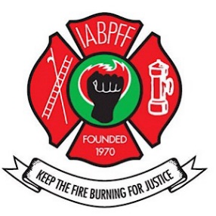
Forms may be requested from your NWR Regional Treasurer or IABPFF Treasurer
INTERNATIONAL ASSOCIATION OF BLACK PROFESSIONAL FIRE FIGHTERS, INC
NORTH WEST REGION

DUES ARE DUE: January 1, 2024

All checks for dues must be made payable to the IABPFF with the 2024 Chapter Dues Submittal Form.

The following information is required:

- Completed Dues Submittal Form
- Payment
- 2024 IABPFF Membership Roster Form
- Must include your chapter number.
- The 2024 Dues Submittal Form, Excel Roster, and Copy of Payment shall be forwarded by email to:

A) NWR Treasurer Norris Edwards: ignorris@hotmail.com
B) IABPFF Treasurer Gwendolyn Sistare: gsistare@iabpf.org
C) Financial Secretary Sharon Branch: sbranch@iabpf.org

Dues will be assessed as follows:

- $47.00 dues per member per year with 25% of that given to region.
- $3.00 Foundation fund per member per year.
- $100.00 IABPFF assessment fee per chapter, per year.
- All dues are due January 1, 2024; a 10% late fee shall be included for payments received after March 1, 2024.

Send dues payment, excel spreadsheet roster, and form to:

IABPFF Treasurer
Gwendolyn Sistare
P O Box 91104
Washington, DC 20090

