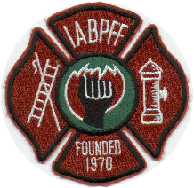
INTERNATIONAL ASSOCIATION OF BLACK PROFESSIONAL FIREFIGHTERS
06-02-2020
IABPFF Health & Safety Update:

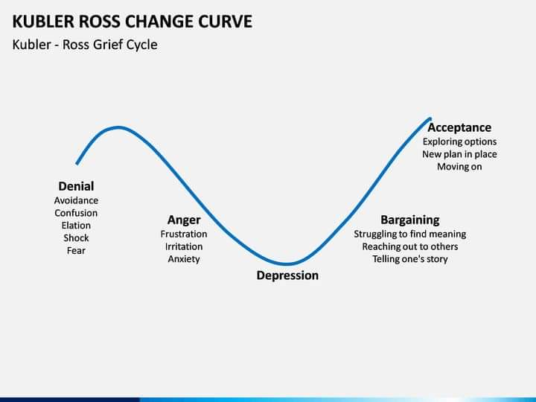
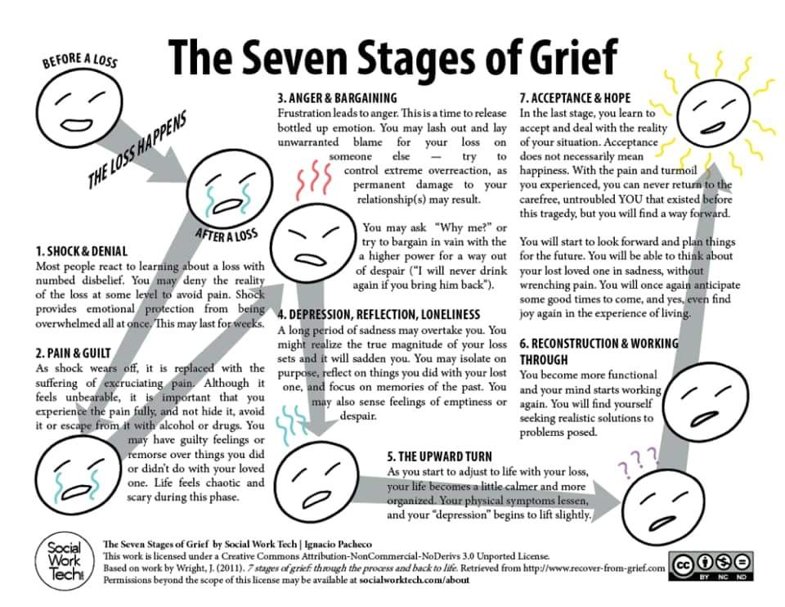

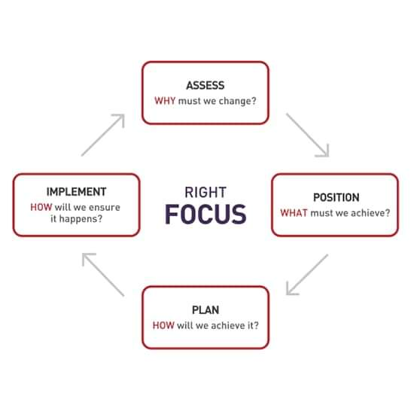
“Please make wise decisions during these unprecedent times”

Please Stay Safe,

Terri L. Reid
IABPFF Health & Safety Chairperson
ser1stvicedirector@gmail.com
443-992-2760
"Reshaping the Future"

