*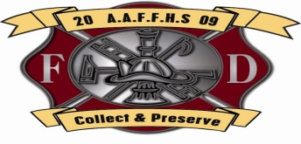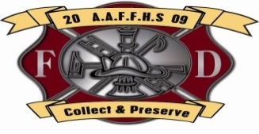2901 Druid Park Drive Suite #402*

*Baltimore, Md. 21215*

*(410) 258 – 7546*

[*www.africanamericanfirefightershistoricalsociety.org*](http://www.africanamericanfirefightershistoricalsociety.org)

[*AAFFHS54@gmail.com*](mailto:AAFFHS54@gmail.com)

***African American Fire Fighters Historical Society***

January 23, 2009 – January 23, 2021

Please allow me to introduce you to ***The African American Fire Fighters Historical Society (AAFFHS)***. The African American Fire Fighters Historical Society’s mission is to collect, preserve and disseminate historical data, and information relating to the contributions made by fire fighters of color, and others who have made a contribution to such history; to be used for the purpose of education, fire prevention and mentoring. AAFFHS is a 501C (3), whose Annual Salute Dinner Honors African American fire fighters. The only event of its kind in the world, is the Signature of our brand.

All honorees over the last 12 years were very deserving of their recognition. Most have never had their contributions acknowledge. These individuals are humble men and women, who were doing what needed to be done.

The African American Fire Fighters Historical Society is always interested in individuals who may be first to have accomplished a goal, such as *getting promoted, filling a position* or to those who have *performed a heroic act*. We also like to have information about organizations who have reached any *historic milestone or anniversary*, as it pertains to African American fire fighter’s history. In addition, we like to recognize *significant dates* in fire service history in which *African Americans played a role*. As The AAFFHS reaches its 12th Anniversary, we are working to establish a brick and mortar extension, The International Black Fire Fighters Museum & Safety Education Center. Below are a few accomplishments we have contributied to fire service history.

* Requested and had submitted a half dozen statements to The United States Congressional Record
* Presented approximately 200 flags flown over the U.S. Capitol on significant dates to distinguish our honorees accomplishments.
* Obtained well over 500 Citations, Proclamations, Resolutions, Certificates of Recognition and Letters of Acknowledgment for honorees.
* Successfully passed Legislation to have a fire house named for an honoree.
* Instrumental in building partnerships, financing the design and advocating. government in establishing ***The Racheal M. Wilson Memorial Park*** a ***LOD*** casualty.

***Please feel free to share with us any thoughts to help continue our mission.***