Forms are available online at www.iabpf.org

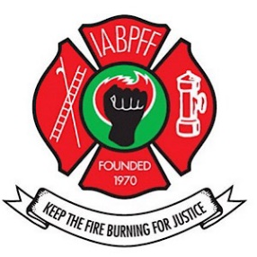
Forms may be requested from your SWR Regional Treasurer or IABPFF Treasurer
INTERNATIONAL ASSOCIATION OF BLACK PROFESSIONAL FIRE FIGHTERS, INC

SOUTH WEST REGION

DUES ARE DUE: January 1, 2023

All checks for dues must be made payable to the SWR with the 2023 Chapter Dues Submittal Form.
The following information is required:

- Completed Dues Submittal Form
- Payment
- 2023 IABPFF Membership Roster Form
- Must include your chapter number.
- Member must current a profile at iabpf.org.
- The 2023 Dues Submittal Form, Excel Roster, and Copy of Payment shall be forwarded by email to:

A) SWR Treasurer Lionel Newby: iabpffswr@gmail.com
B) IABPFF Treasurer Gwendolyn Sistare: gsistare@iabf.org
C) Financial Secretary Sharon Branch: sbranch@iabpf.org

Dues will be assessed as follows:

- $47.00 dues per member per year with 25% of that given to region.
- $3.00 Foundation fund per member per year.
- $100.00 IABPFF assessment fee per chapter, per year.
- All dues are due January 1, 2023; a 10% late fee shall be included for payments received after March 1, 2023.
- $30.00 per member SWR dues

Send payment with dues submittal form to:

SWR TREASURER
LIONEL NEWBY
PO BOX 751453
LAS VEGAS, NV 89136

