Forms are available online at www.iabpf.org

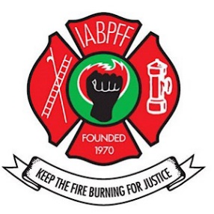
Forms may be requested from your NER Regional Treasurer or IABPFF Treasurer
INTERNATIONAL ASSOCIATION OF BLACK PROFESSIONAL FIRE FIGHTERS, INC
NORTH EAST REGION

. DUES ARE DUE: January 1, 2023

All checks for dues must be made payable to the NER with the 2023 Chapter Dues Submittal Form.
The following information is required:

- Completed Dues Submittal Form
- Payment
- 2023 IABPFF Membership Roster Form
- Must include your chapter number.
- Member must current a profile at iabpf.org.
- The 2023 Dues Submittal Form, Excel Roster, and Copy of Payment shall be forwarded by email to:

A) NER Treasurer Alton Dickson: fireexpo91@aol.com
B) IABPFF Treasurer Gwendolyn Sistare: gsistare@iabf.org
C) Financial Secretary Sharon Branch: sbranch@iabpf.org

Dues will be assessed as follows:

- $47.00 dues per member per year with 25% of that given to region.
- $3.00 Foundation fund per member per year.
- $100.00 IABPFF assessment fee per chapter, per year.
- All dues are due January 1, 2023; a 10% late fee shall be included for payments received after March 1, 2023.
- $200.00 per chapter NER dues

Send payment with dues submittal form to:

NER Treasurer
Alton Dickson
214 New St
Orange, NJ 07050

