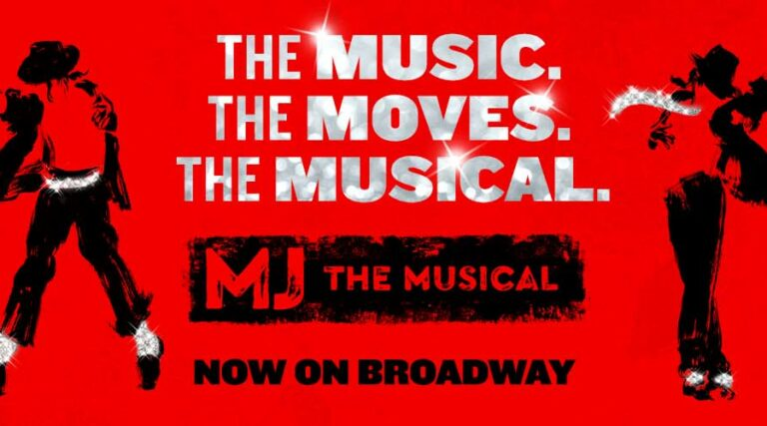

Greetings IABPFF family,
A wonderful package for a trip day in NYC was put together for you and your loved ones The information for the trip is below. Please let me know as soon as possible if you are interested. I need a minium of 20 people in order for the trip to take place. If you have any questions or concerns please contact me at 718-749-7633 or at Rwilsonvs@gmail.com. Here is a preview of the musical https://fb.watch/erNQdYg-jw/
Regina
# of  Paying  Pass | # of  Comps | Orchestra 1/  Front  Mezzanine | Orchestra 2/ Mid Mezz 1 | Mid  Mezzanine 2 | Rear  Mezzanine
52 Passenger Coach |  | Per person | Per person | Per person | Per person
40 | 2 | $279 | $229 | $219 | $189
35 | 2 | $289 | $239 | $229 | $199
36 Passenger Coach
30 | 2 | $299 | $249 | $239 | $209
20 | 2 | $349 | $289 | $279 | $249

Date of Trip: Thursday August 25, 2022 Destination: New York City
Features Inc:
RT Transportation on a premium 36/52 passenger motorcoach
10:30am Depart Hartford, CT
Lunch at Tony DiNapoli
-1 Salad, 1 App, 3 Pastas, 3 Entrees (no seafood) served family style
-Coffee, tea, Homemade tiramisu, Italian Cheesecake & Mini Cannoli’s
Free afternoon time in the city
**Tickets to MJ the Musical- 7pm Show
Depart for home after the show
DATTCO Driver Gratuity Included

*Tour features are not being held at this time and are subject to availability at the time of booking.

