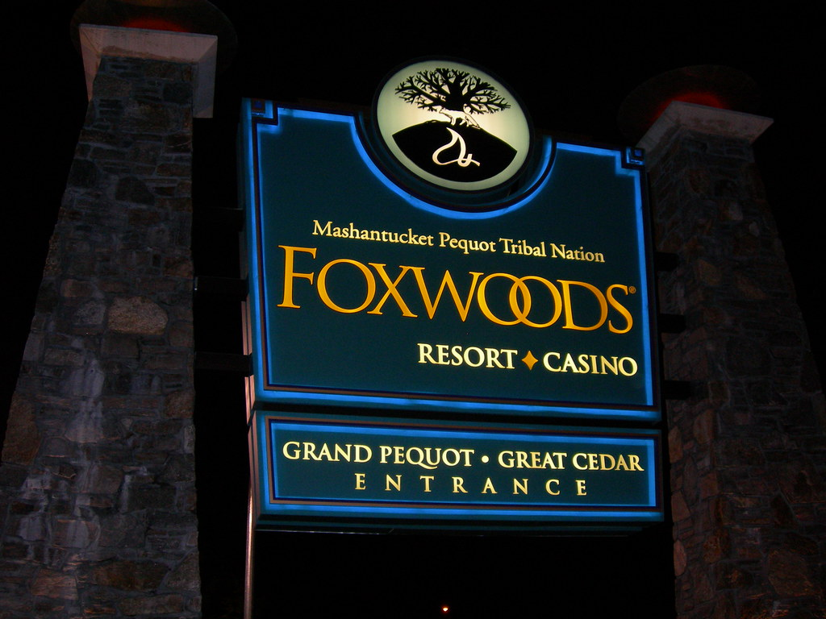

[This Photo](http://www.flickr.com/photos/auvet/285137666/) by Unknown Author is licensed under [CC BY-NC-ND](https://creativecommons.org/licenses/by-nc-nd/3.0/)

ARE YOU READY

Come and join us for shopping and winning at the Grand Pequot Foxwood Casino and Premium Outlet.

Tuesday Aug 23, 2022

Transportation leaves at 1100am from the Hotel and will return at 6pm from the Foxwoods Casino.

“We ask that you enjoy and that your driver enjoys also”

This is the NER “ALL THE WAY UP”