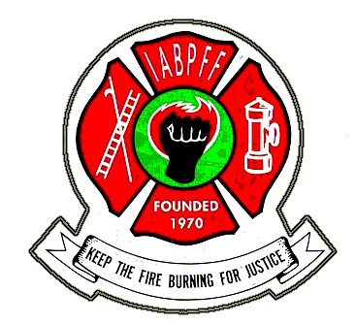
2022 SWR IABPFF CHAPTER DUES SUBMITTAL FORM

REGION OF THE INTERNATIONAL ASSOCIATION OF BLACK PROFESSIONAL FIRE FIGHTERS

Date: _________________ Dues are due on January 1, 2022

Chapter: ____________________________________________________________________________________

Address: ____________________________________________________________________________________

City: _________________ ______ _________ State: ____ Zip: _____________

President's Name: _____________________________________________________________________________

Phone #: ____________________ Email: ___________________________________________________________

Treasurer Name________________________________________________________________________________

Phone #: ____________________ Email: ___________________________________________________________

Chapter Number: ___________ Roster Date: _____________ Number of Members: _____________

DUES AMOUNT SUBMITTED (make check payable to NCR)

1. IABPFF National Chapter Assessment: $100.00

2. IABPFF Dues: $47.00 x (# of members) $______________

3. Foundation Fund Dues: $3.00 x ______ (# of members) $______________

4. Late Fees (after January 1st) 10% x line 2 $______________

5. SWR Chapter Dues: $30.00 x ______ (# of members) $ _____________

6. Total Amount Paid (add lines 1 thru 5) $______________

Submit dues payment & form to:
SWR TREASURER, LIONEL NEWBY
PO BOX 751453, LAS VEGAS, NV 89136

For Regional Treasurer Use Only

Line 6, total amount submitted $ ___________________

Deduct line 5 $ ___________________subtract

Deduct 25 % of line 2 $ ___________________subtract

Submit balance to IABPFF Treasurer $___________________

