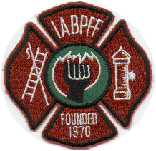
INTERNATIONAL ASSOCIATION OF BLACK PROFESSIONAL FIREFIGHTERS
09-11-2020
IABPFF Health & Safety Update:

Firefighters lost at the World Trade Center 9/11/01
Gerard Jean Baptiste, 35, Ladder 9. He was a former National Guardsmen who was working toward becoming an officer in the fire department. Baptiste was known to carry dog biscuits in his pockets for pets being walked past the fire house.
Vernon P. Cherry, 49, Ladder 118. Cherry, a 28-year veteran of the fire department was a husband and father who also moonlighted as a wedding singer. He also won over his colleagues as a cook, using every pot in the fire house for his famous lasagna.
Tarel Coleman, 32, Squad 252. Coleman was a defensive back on the FDNY's football team. He was destined to become a firefighter, after he singed off his eyebrows as a child when he stuck his head into the incinerator of his family's apartment building.
Andre Fletcher, 37, Rescue Company 5. Fletcher and his brother Zackary were the only African-American twins in the New York City fire department. He organized the department's baseball team and played wide receiver on the football team. He and his brother both responded to the World Trade Center on 9/11. His brother is made it out safely.
Keith A. Glascoe, 38, Ladder 21. Glascoe was a husband and father of three. He was a towering figure who stood 6 feet 4 inches tall and about 270 pounds; he was twice invited to the New York Jets' training camp. He was also a budding actor, appearing in television commercials and on shows such as "One Life to Live" and "Law and Order."
Ronnie L. Henderson, 52, Engine Company 279. Henderson was a husband and father of four who had also served as a member of the United States Marine Corps. Henderson helped to raise five younger siblings and always urged them to save money and make their education a priority. He was remembered as thrifty, studying maps to find routes that avoided tolls and investing his savings in the stock market.
Vernon A. Richard, 53, Ladder 7. Richard was a 24-year veteran of the fire department who rose to the rank of Lieutenant. He was killed two months before he was expected to be promoted to captain. Richard was a husband and father who loved roller coasters, sang in his church choir and ran in six New York City Marathons. He was also active in the Vulcan Society, an organization for black FDNY firefighter.
Shawn E. Powell, 32, Engine 207. Powell, a husband and father of a son, was an artist who, aside from his duties as a firefighter, built props and volunteered for city theaters, including the Apollo Theater. Before joining the fire department, Powell served four years in the Army.
Keithroy M. Maynard, 30, Engine 33. Maynard was a father of one who served as an executive board member of the Vulcan Society, an organization of black firefighters in the FDNY. He was an outspoken member of the organization who followed his father, a New York City fireman for 36 years, into the department. Though he loved his job, Maynard was an outspoken critic of the department's lack of diversity and was determined to help change things. He would visit black neighborhoods and recruit applicants for the force.
Karl H. Joseph, 25, Engine 207. Joseph was known for his hard work and quiet disposition. He was a probationary firefighter who had joined the department a year before September 11. He came to America from Haiti as a child, with his parents and eight siblings.
William L. Henry Jr., Rescue 1. Henry was a 20-year veteran of the department who was active in helping to recruit and train African-American firefighters. He enjoyed playing paddle tennis and traveling to exotic locales like Brazil. His family and his job were the loves of his life.
Leon W. Smith Jr., 48, was a father of three daughters. He was the driver for Ladder Company 118. Smith grew up across the street from a fire house and at the age of nine proclaimed to his mother that he wanted to be a firefighter. Smith was a gifted mechanic who is remembered for his positive nature and strong will.

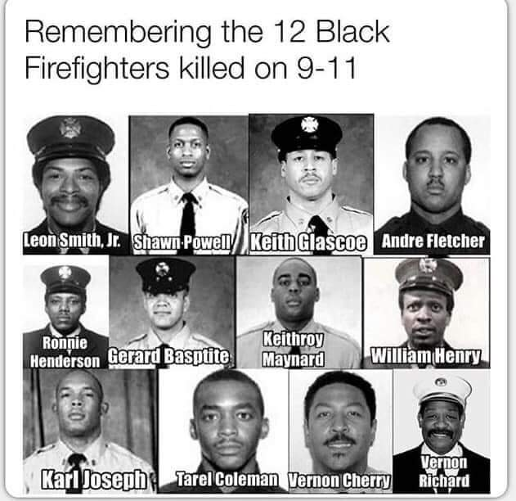

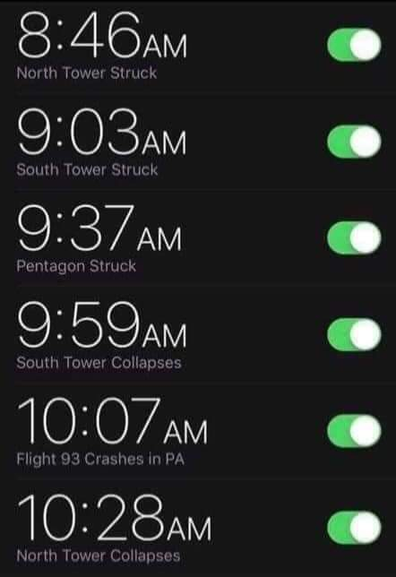

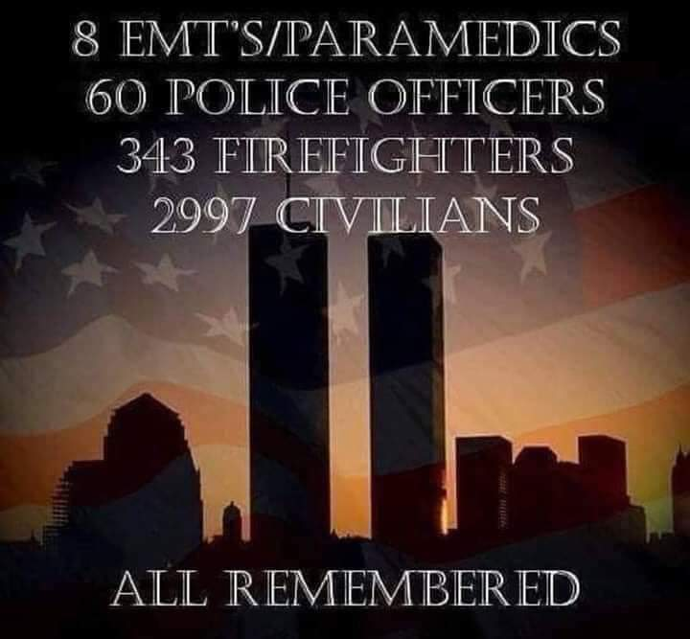

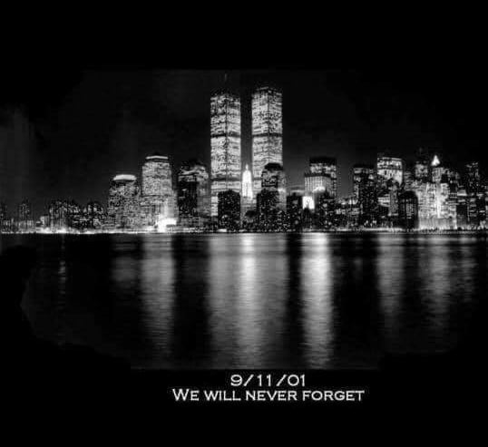

Please Stay Safe,

Terri L. Reid
IABPFF Health & Safety Chairperson
ser1stvicedirector@gmail.com
443-992-2760
"Reshaping the Future"

Please Stay Safe,

Terri L. Reid
IABPFF Health & Safety Chairperson
ser1stvicedirector@gmail.com
443-992-2760
"Reshaping the Future"
