INTERNATIONAL ASSOCIATION OF BLACK PROFESSIONAL FIREFIGHTERS
08-20-2021
IABPFF Health & Safety Update

Good Morning IABPFF Family & Friends,

Unfortunately, we are still dealing with the COVID-19 pandemic. Currently we have types of COVID-19 Variants present and it’s important to shed awareness to our Members, Family and our communities we serve.

.

Top Things You Need to Know
- Variants are expected. The best way to slow the emergence of new variants is to reduce the spread of infection by taking measures to protect yourself including getting a COVID-19 vaccine when available.
- Vaccines keep you from getting sick, being hospitalized, or dying from COVID-19.
- All COVID-19 tests can detect all variants, but they will not tell you which variant you have.

Types of COVID-19 Variants
Scientists monitor all variants but may classify certain ones as variants of interest, concern, or high consequence based on how easily they spread, how severe their symptoms are, and how they are treated.
Some variants seem to spread more easily and quickly than other variants, which may lead to more cases of COVID-19. An increase in the number of cases will put more strain on healthcare resources, lead to more hospitalizations, and potentially more deaths.

Variants of Concern in the US

Alpha - B.1.1.7
First identified: United Kingdom
Spread: Spreads much faster than other variants
Severe illness and death: May potentially cause more people to get sicker and to die
Vaccine: Currently authorized vaccines do work against this variant. Some breakthrough infections in fully vaccinated people are expected but remain rare. All vaccines are particularly effective against severe illness, hospitalization, and death.
Treatments: Treatments are effective against this variant

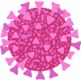

Beta - B.1.351
First identified: South Africa
Spread: May spread faster than other variants
Severe illness and death: Current data do not indicate more severe illness or death than other variants
Vaccine: Currently authorized vaccines do work against this variant. Some breakthrough infections are expected, but remain rare. All vaccines are particularly effective against severe illness, hospitalization and death.
Treatments: Certain monoclonal antibody treatments are less effective against this variant

Gamma - P.1
First identified: Japan/Brazil
Spread: Spreads faster than other variants
Severe illness and death: Current data do not indicate more severe illness or death than other variants
Vaccine: Currently authorized vaccines do work against this variant. Some breakthrough infections are expected, but remain rare. All vaccines are particularly effective against severe illness, hospitalization and death.
Treatments: Certain monoclonal antibody treatments are less effective against this variant.

Delta - B.1.617.2
First identified: India
Spread: Spreads much faster than other variants
Severe illness and death: May cause more severe cases than the other variants
Vaccine: Infections happen in only a small proportion of people who are fully vaccinated, even with the Delta variant. Some breakthrough infections are expected, but remain rare. However, preliminary evidence suggests that fully vaccinated people who do become infected with the Delta variant can spread the virus to others. All vaccines are particularly effective against severe illness, hospitalization and death.
Treatments: Certain monoclonal antibody treatments are less effective against this variant

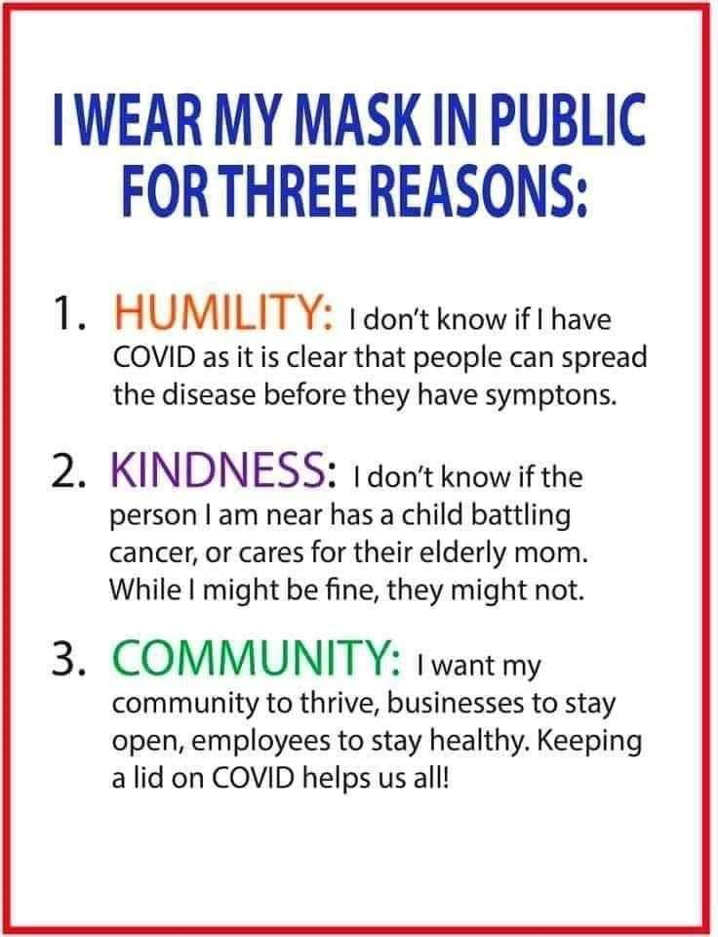

Please Stay Safe,

Terri L. Reid
IABPFF Health & Safety Chairperson
ser1stvicedirector@gmail.com
443-992-2760
"Reshaping the Future"

