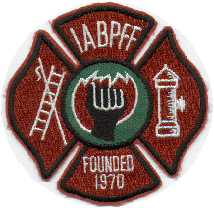
INTERNATIONAL ASSOCIATION OF BLACK PROFESSIONAL FIREFIGHTERS
08-03-2020
IABPFF Health & Safety Update:

Good morning IABPFF Family,

Please see the attached in reference to Firefighter Cancer Fact Check. Pass this information to your respective Chapters and Individual members to view. If I can provide you additional information please don’t hesitate to reach out to me.

Please Mask Up & Stay Safe,

Terri L. Reid
IABPFF Health & Safety Chairperson
ser1stvicedirector@gmail.com
443-992-2760
"Reshaping the Future"

