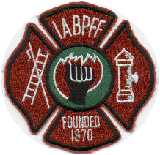
INTERNATIONAL ASSOCIATION OF BLACK PROFESSIONAL FIRE FIGHTERS

IABPFF Health & Safety COVID-19 Update

Greetings IABPFF Members & Families,

I want to take this brief opportunity to update our IABPFF members and families regarding to the novel coronavirus (COVID-19) outbreak. I am sure our members are trying to keep up to date with this constantly changing situation. The CDC has declared a pandemic. The IABPFF Health & Safety Team has been in contact with the Federal and Local government making sure our members are protected. I encourage all IABPFF members to log onto the cdc.gov website as the IABPFF Health & Safety Team is monitoring the CDC for best practices. The International has a plethora of information readily available with various links to all your needed resources and best practices. Any IABPFF Region having any planned upcoming events should highly consider postponing them as we continue to closely monitor COVID-19. We have the responsibility to keep our members, families and the communities safe and reduce the risk of exposure to COVID-19.

Attached are a few helpful guidelines to keep you and your families safe. Please remain vigilant on following proper Personal Protective Equipment precautions as we go about our daily activities.

Stay Safe,

Terri L. Reid
IABPFF Health & Safety Chair
443-992-2760
"Reshaping the Future"

