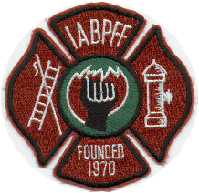
INTERNATIONAL ASSOCIATION OF BLACK PROFESSIONAL FIREFIGHTERS
07-09-2020
IABPFF Health & Safety COVID-19 Update

Good morning IABPFF Family,

Below is some information in reference to “Know your risk during COVID-19 curiosity of IABPFF Past President Brother Muhammad. As we continue to do soft openings of public places we are noticing an increase of positive COVID-19 patients. Please understand we are still in unchartered waters and have not established a cure for COVID-19. Be open minded, vigilant and safe conducting our day to day activities. Please continue to utilize your facemask and social distance techniques.

“IABPFF Task up….. Is to Mask Up”

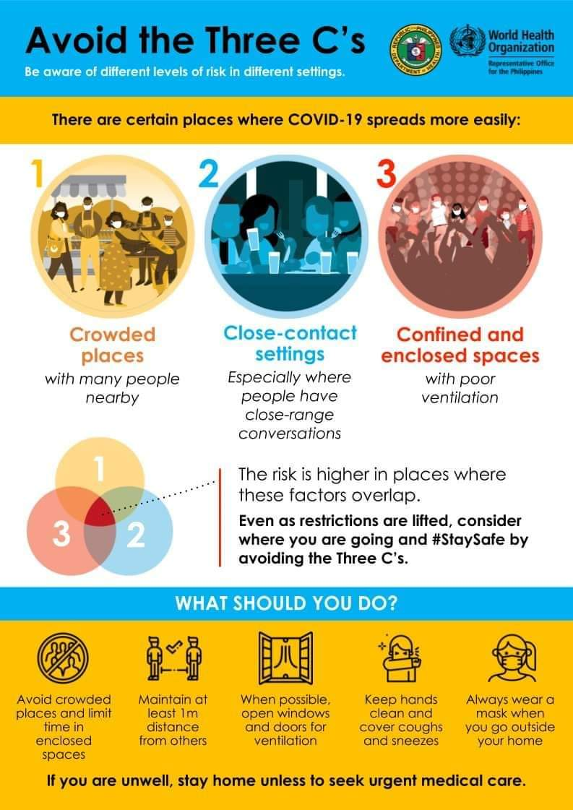

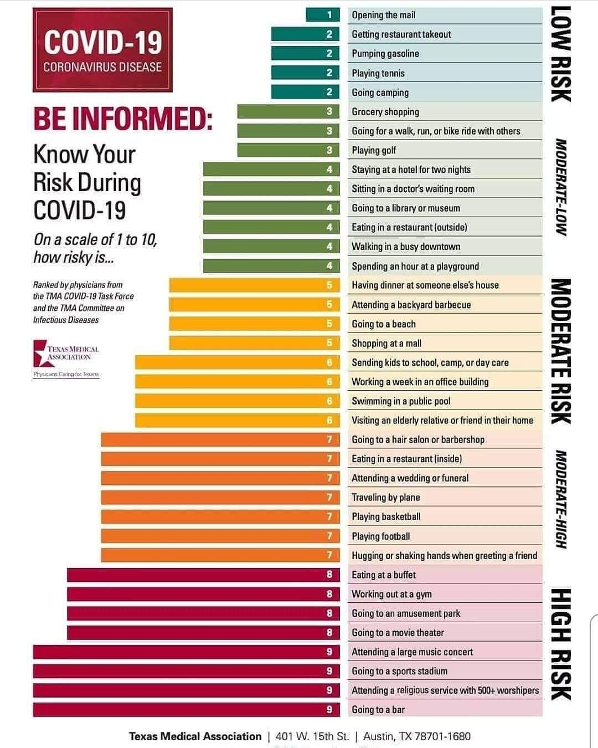
Please Stay Safe,

Terri L. Reid
IABPFF Health & Safety Chairperson
ser1stvicedirector@gmail.com
443-992-2760
"Reshaping the Future"

