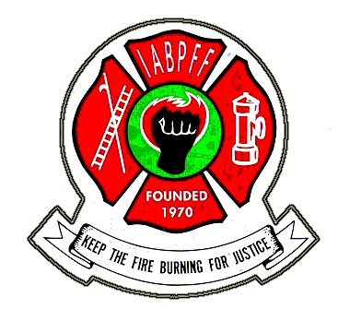
SOUTH WEST REGION
REGION OF THE INTERNATIONAL ASSOCIATION OF BLACK PROFESSIONAL FIRE FIGHTERS

2021 IABPFF CHAPTER DUES SUBMITTAL FORM

Date:________________________________________________________________

Chapter Name: ________________________________________________________

Address: _____________________________________________________________

City: State: Zip: ________________

Phone: Fax: ________________

Chapter President: ______________________________________________________

Email: ________________________________________________________________

Chapter Treasurer: ______________________________________________________

Email: _________________________________________________________________

Chapter Number _________ Roster Date: Number of Members: __________

DUES AMOUNT SUBMITTED:

1. IABPFF Chapter Assessment $100.00

2. IABPFF Dues: $47.00 x _ (# of members) $____________ ____

3. Foundation Fund: $3.00 x ___________ (# of members) $_________________

4. Late Fees (after March 1st) add 10% x line 2 $_________________

5. SWR Dues: $30.00 x _________ (# of members) $_________________

6. Total Amount Paid $________________

Make Check payable to SWR, submit to:

LIONEL NEWBY
SWR TREASURER
PO BOX 751453
LAS VEGAS, NV 89136

For Treasurer Use Only
Line 6, total amount submitted $ _______________
Deduct line 5 $ ________________subtract
Deduct 25 % of line 2 $ ________________subtract

Submit balance to IABPFF Treasurer $______________

IABPFF Treasurer Gwendolyn Sistare PO Box 91104 Washington, DC 20090

