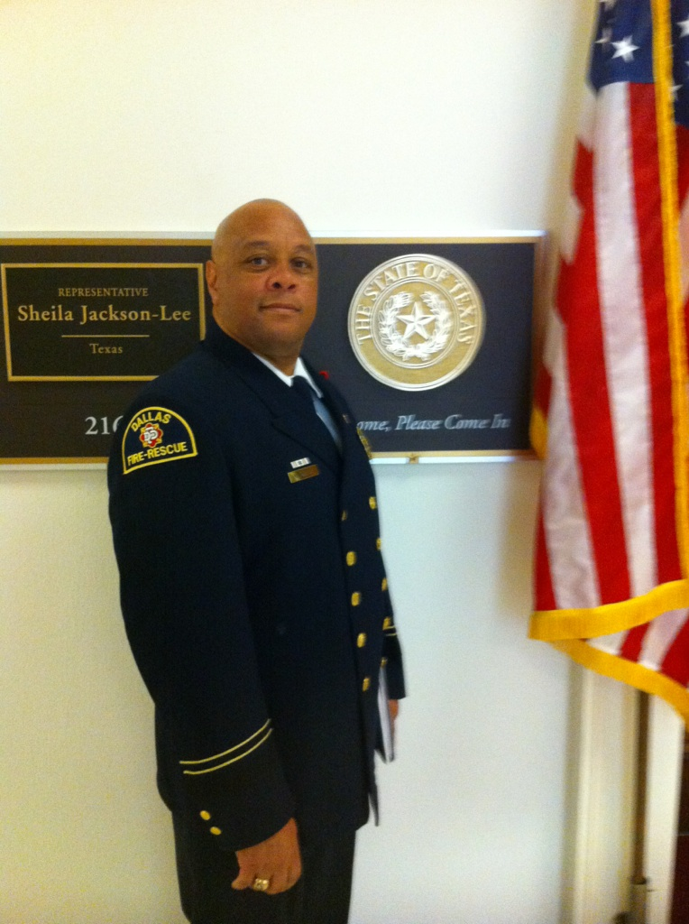
SHAWN GARY
1830 PARK ROW
DALLAS, TEXAS 75215

Fire Marshal for the City of Lancaster, Texas/Master Firefighter Shawn Gary was a proud member of the Dallas Fire-Rescue, Dallas Black Fire Fighters Association, and Deputy Assistant Director for the South Central Region. He has promoted and diversified his fire service career through Master Firefighter, Master Fire Investigator, Texas Fire Officer II, Master Fire Inspector, and Texas Hazardous Material Technician.

Shawn Gary was born and raised in Paducah, Kentucky. Where he first was introduced to public service as a juvenile officer for McCracken County Kentucky. Fire service was introduced to Shawn Gary at Lansing Community College with a Certificate of Firefighting I & II by the State of Michigan. In 1994 Dallas Fire-Rescue swore him in as a Fire Rescue Officer.

Shawn Gary has continued to his career with upward mobility by accomplishments such as Kentucky Emergency Medical Services Certificates, Michigan Fire Commission Certificates, Texas Emergency Medical Services Certificates, and Texas Fire Commission Certificates. As a active member of the IABPFF, Shawn has served on numerous city, state, and national committees. A consistent attendee of the US Fire Academy, US FEMA Grant Review, and Graduate of Carl Holmes Executive Development Institute at Dillard University. Shawn has also served on myriad of community, business, and professional organizations at local and state levels.

Shawn Gary has been happily married to his hometown sweetheart Yolanda for 30 years. They are the proud parents of Sereniti, Symone, and Shawn Gary II.

