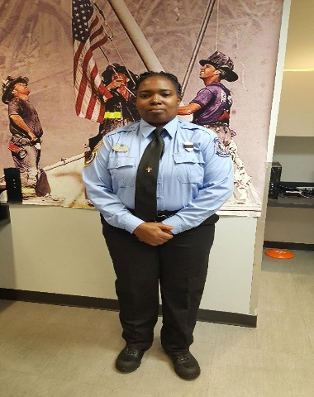Tonia J Reed
$$A child of God, A mother, and A firefighter.$$

Hello all, my name is Tonia J. Reed an I was born in Tampa, Florida and I the oldest of 5 children on my mother side and somewhere in the mix of over 30 children on my father side who play for the Knicks in the late 60’s and early 70’s. I am a child of God, who is the head of my life. I am mother of one child, a daughter who is married and a grandmother of two very energetic and vibrant grandsons.
I started my career in Tallahassee, Florida as a volunteer firefighter for Tallahassee Fire Department in the community of Chaires/Capitola. I attended the fire academy at Chipola College in Marianna with financial assistance from a black firefighter organization called Capital City Firefighters of Tallahassee, Florida and EMT school at Taylor Technical Institute in Perry, Florida.
Currently I am a firefighter/ paramedic at Reedy Creek Improvement District the city for Walt Disney World in Orlando, Florida. I am a member of IABPFF/ SER, as well as a graduate of Carl Holmes EDI class of 2019. I currently attending Columbia Southern University, majoring in Fire Investigation Administration.
I am someone who believes in constantly improving myself when it comes to my skills, education, training for myself and other around me. I believe Servant Leadership, which means that the main goal of the leader is to help and empower others to strive for greatness. I have been a advisor for Polk County Fire Department Explorers/ Cadet program for over 8 years.
Community service is something I have a great passion for. In the past I have started a couple of community service projects such as a bicycle and helmet give-away for 8 years, a winter sock and blanket drive, a Thanksgiving dinner purchase and give-away for 4 years and hurricane relief drives for Irma and Michael. Also, I have been apart of many different community service organization as a volunteer, such as Amazing Love feeding ministry, Feeding the Bay ministry, Metropolitan homeless ministry and volunteering at the cold weather shelters.
I serve because I want to be useful to others.

Tonia J. Reed
All that I am I owe, I live eternally in the Red.

